International Referee Seminars: Useful Information

The International Referee Seminars are just around the corner. Please see below for seminar details including transportation, seminar schedule, s shuttle bus information and more.

Please contact Darryl Elyk at ir@taekwondo-canada.com if you have any questions.

Seminar schedule:

Poomsae International Referee Seminar: 9am - 6pm, May 6th-9th
Kyorugi International Referee Seminar: 9am - 6pm, May 10th-13th

Seminar Location:

Hilton Vancouver Metrotown: Tiffany Ballrooms (main floor)
Address: 6083 McKay Avenue, Burnaby, British Columbia V5H 2W7

Accreditation/Payment:

You can pay for the seminar and pick up your accreditation on May 6th and 10th, before the start of each seminar.
You might also be able to register and pay for the seminar on May 5th, from 2-6pm, at the host hotel.

Lunch and Dinner:

Within walking distance you find many restaurants.
You can search for restaurants near the host hotel or other points of interest using this link:
https://www.tripadvisor.ca/Restaurants-g181793-Burnaby_British_Columbia.html#MAPVIEW

Cash exchange:
You will find at least three currency exchange services near the host hotel.

Hotels and transportation:
Host Hotel (Seminar venue): Hilton Metrotown Vancouver
- Address: 6083 McKay Avenue, Burnaby, BC V5H 2W7
Secondary Hotel: Best Western Kings Inn
- Address: 5411 Kingsway Street, Burnaby, BC, V5H 2G1

Between Hotels: Free Shuttle Bus
Morning shuttle:
- Best Western Plus (7:50am) -> Hilton (6th and 10th only)
- Best Western Plus (8:10am) -> Hilton
- Best Western Plus (8:30am) -> Hilton
- Best Western Plus (8:50am) -> Hilton
Return shuttle:
- Hilton (6:20pm) -> Best Western Plus
- Hilton (6:40pm) -> Best Western Plus
- Hilton (7:00pm) -> Best Western Plus
****Spots are limited. Please take the shuttle as early as possible.

Airport to Hotels: SkyTrain
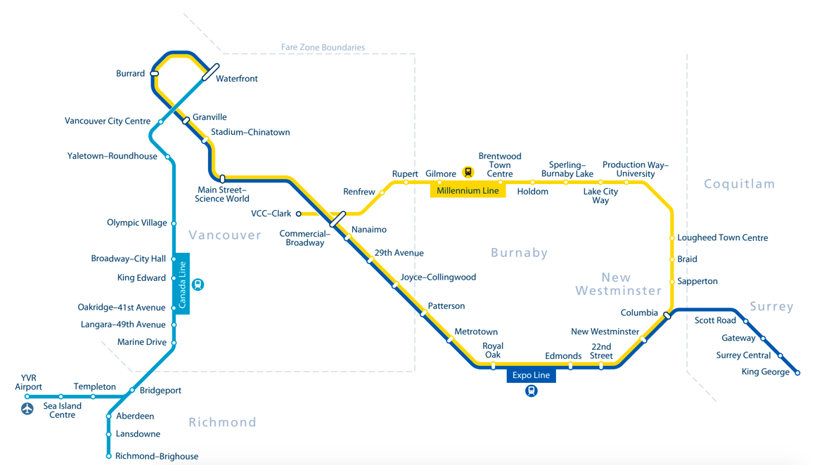

YVR Airport -> Hilton Vancouver Metrotown Hotel: by SkyTrain
- Take the Canada Line from the YVR Airport (Direction: Waterfront)
- YVR Airport Station -> Vancouver City Centre Station
- Change to the Expo Line (Direction: Production Way-University)
- Granville Station -> Metrotown Station
- Arrived at Metrotown Station and walk to the Hilton Vancouver Metrotown (destination)

YVR Airport -> Best Western Kings Inn: by SkyTrain
- Take the Canada Line from the YVR Airport (Direction: Waterfront)
- YVR Airport Station -> Vancouver City Centre Station
- Change to the Expo Line (Direction: Production Way-University)
- Granville Station -> Royal Oak Station
- Arrived at Royal Oak Station and walk to the Best Western Kings Inn (destination)

You can find SkyTrain Schedule Information here: https://www.translink.ca/Schedules-and-Maps/SkyTrain/SkyTrain-Schedules/Expo-Line.aspx

