 

**Taekwondo Canada**

**Analyzing Taekwondo Performance**

**Portfolio**

**Competition-Development**





The programs of this organization are funded in part by Sport Canada.

cdnheritage

Printed in Canada

© This document is copyrighted by the Coaching Association of Canada and Taekwondo Canada (2014) and its licensors. All rights reserved.

Acknowledgments

The Taekwondo Canada would like to acknowledge the following people for their contribution in the development of this document.

David Hill (Consultant)

Ken Anstruther

Jamie Dossantos

Tino Dossantos

Shin Lim

GM Young Choung

Dominique Bosshart

|  |  |
| --- | --- |
| **Revision** | **Date** |
| Module Created | 2014 |
| Module Updated with committee post pilot | June 2014 |

**Performance Coach**

**Taekwondo Analyzing Performance Checklist**

|  |  |  |  |  |
| --- | --- | --- | --- | --- |
| **Date** |  | | | |
| **Coach** |  |  | **CC number:** |  |
| Surname | First Name |  | |

|  |  |  |  |
| --- | --- | --- | --- |
|  | **Portfolio Requirements** | **Check** | **Date (dd/mm/yyyy)** |
| **Tasks** | Task 1 – Determinants or Performance   * Submit a completed deterministic model for a skill that is performed in competition. * The model would include:   + Hierarchy of determinants   + Biomechanical principles   + Measuring Strategy |  |  |
| Task 2 – Key Performance Indicators   * Demonstrate use of video to break down a skill and show key determinants based on model. * Demonstrate use of video to provide feedback on technique with an athlete. * The video could be:   + Edited video uploaded to Youtube or Vimeo   + Use of App (Ubersence / Coach my Video) uploaded to Youtube or sharing applications. |  |  |
| Task 3 – Notational Analysis   * Categorize a fight into different movement phases or techniques. * Analyze a fight using own athlete to determine frequency of measures. * Present data summary and interpretation of result. * Make recommendations for future tracking or analysis. |  |  |

**PORTFOLIO MARKING CHECKLIST**

|  |  |  |  |
| --- | --- | --- | --- |
| ***Check*** | | ***Evidence of Achievement*** | ***Comments*** |
| **Detect Technique** |  | **Show optimal angle of observation** |  |
|  | **Clearly articulates performance outcome** |
|  | **Identifies potential causes/determinants** |
|  | **Communicate how and why KPI impacts perf** |
|  | **Identifies optimal timing in execution** |
|  | **Determines impact of technique on tactics** |
|  | **Identify injury risk due to poor technique** |
|  | **Apply biomechanical principles** |
|  | **Makes use of technology in analysis** |
|  | **Selects variety of observational strategies** |
|  | **Facilitates athletes to analyze own perf.** |
|  | **Mentor other coaches in technique detection** |
| **Detect Tactics** |  | **Provides notational analysis of opponents** |  |
|  | **Provides notational analysis of own athlete** |
|  | **Identify techniques to enable tactics** |
|  | **Identify tactical intention in relation to strategy** |
|  | **Identifies potential causes / determinants** |
|  | **Reinforce competitive rules** |
|  | **Identify optimal decision making cues** |
|  | **Identify programming decisions** |
|  | **Makes use of technology in analysis** |
|  | **Selects a variety of observational strategies** |
|  | **Facilitates athletes to analyze own perf.** |
|  | **Mentor other coaches in technique detection** |

**PORTFOLIO MARKING CHECKLIST**

|  |  |  |  |  |  |  |
| --- | --- | --- | --- | --- | --- | --- |
| ***Check*** | | ***Evidence of Achievement*** | | | | ***Comments*** |
| **Report on progress** |  | **Present assessment of relevant performance** | | | |  |
|  | **Communicate steps for improvement** | | | |
|  | **Debrief athletes on performance** | | | |
|  | **Protect privacy of information** | | | |
|  | **Optimally timing of athlete reporting (YTP)** | | | |
|  | **Good use of communication** | | | |
|  | **Provide objective feedback on performance** | | | |
|  | **Track changes in performance over time** | | | |
|  | **Facilitate athletes to monitor own performance** | | | |
|  | **Design assessment tools and strategies** | | | |
| Rank  ***(NI, MS, ES)*** | | | ***Criteria*** | | | |
|  | | | Detect tactical elements that have to be improved or refined to enhance performance | | | |
|  | | | Detect technical elements that have to be improved or refined to enhance performance or reduce injuries | | | |
|  | | | Report on athlete progress throughout the program | | | |
| Evaluator | | | | | | |
|  | | | | |  | |
| Signed | | | | | Date | |
| Evaluator | | | |  |  | |
| Surname | First Name | |

*Evaluators MUST NOT recommend any coach as a Certified if they observe ANY of the following behaviours, as they undermine values of Taekwondo Canada and the National Coaching Certification program.*

* *Any incident of disrespectful, offensive, abusive, racist or sexist comments or behaviours directed towards others, including but not limited to athletes, coaches, officials, administrators, spectators and sponsors.*
* *Repeated unsportsmanlike conduct such as angry outbursts or arguing.*
* *A single physically abusive incident with willful intent to injure*
* *Activities or behaviours that interfere with a competition or with any athlete’s preparation for a competition.*
* *Pranks, jokes or other activities that endanger the safety of others.*
* *Use of techniques or programs that may endanger the safety of others.*
* *Use or promotion of banned performance enhancing drugs or methods.*
* *Willfully and knowingly plagiarizing or copying work from other coaches for the purpose of providing evidence for evaluation.*

*If any of the above actions are observed during the observation, the coach must fail. The incident must be documented and notification sent to Taekwondo Canada. In order to be considered for re-evaluation the coach must initiate an appeal procedure as outlined in the Taekwondo Canada NCCP operations manual*

Task 1 - Deterministic Model

1. Develop a model showing the relationships between the results obtained from a performance and the factors that produce that result.
   * What is the intended outcome? What causes this outcome?
2. Observation of the performance and identification of faults
   * Phases of motion – Key performance factor for each phase
3. Evaluation of the relative importance of these faults
   * Prioritizing the most important KPIs using relation to biomechanics
4. Instruction of the performer in accord with conclusions reached in analysis
   * Applying the model using video feedback with athlete
5. Using the template below to apply a specific skill to the model. You may add new, or cross link determinants depending on the skill you choose.
   * You might consider color code the determinants to relate to biomechanical principles or priorities

Task 1 - Relating the Biomechanical Principles

1. For each of Newton’s Laws and relay the principle in the table below. Identify a skill and determine the required KPI’s (Key Performance Indicators) and outline each relevant phase of movement.

| Skill: | | | |
| --- | --- | --- | --- |
| Newton’s Law | Related Principle | Key Performance Indicators  (Teaching Points) | Phase of Movement |
| **Newton’s First Law:**  **Law of inertia**  **“As long as no net force is applied, an object at rest will remain at rest and an object in motion will continue in motion.”** | **Principle #1: Balance and Stability**   * When athletes want to become stable, they should * When athletes want to move quickly (become less stable), they should |  |  |
| **Principle #6: Angular Motion**   * When athletes want to create motion about a fixed point or fixed axis, they should |  |  |
| **Newton’s Third Law**  **Law of reaction**  **“For every action there is an equal and opposite reaction.”** | **Principle #4: Reaction Forces**   * When athletes want to move in one direction, they should |  |  |
| **Newton’s Second Law**  **Law of acceleration**  **“The acceleration of an object is directly proportional to the force applied and inversely proportional to its mass.”** | **Principle #2 Use All Joints in Order**   * When athletes want to produce maximum speed, they should |  |  |
| **Principle #3: Impulse**   * When athletes want to apply maximum force, they should |  |  |

Task 2 – Key Performance Indicators

* Demonstrate use of video to break down a skill and show key determinants based on model.
* Demonstrate use of video to provide feedback on technique with an athlete.
* The video could be:
  + Edited video uploaded to Youtube or Vimeo
  + Use of App (Ubersence / Coach my Video) uploaded to Youtube or sharing applications.

Task 3 – Notational Analysis

* Categorize a fight into different movement phases or techniques.
* Analyze a fight using own athlete to determine frequency of measures.
* Present data summary and interpretation of result.
* Make recommendations for future tracking or analysis.

**Performance Coach Context: Outcomes, Criteria for Training and Evaluation**

|  |  |  |  |  |
| --- | --- | --- | --- | --- |
| Module | **Outcome** | Criteria | Training | Evaluation |
| Performance Analysis | **Analyze Performance** | Detect tactical elements that have to be improved or refined to enhance performance | Description: logo.JPG**Taekwondo Canada - Performance Analysis**  Webinar 6: Determinants of skilled performance  Webinar 7: Applying Biomechanical Principles  Webinar 8: Using video for notational Analysis | Task 1 – Determinants or Performance  Task 2 – Key Performance Indicators  Task 3 – Notational Analysis |
| Detect technical elements that have to be improved or refined to enhance performance or reduce injuries |
| **Manage a Program** | Report on athlete progress throughout the program |

| **Outcome: Analyze performance** | |
| --- | --- |
| **Criterion: Detect technical elements that have to be improved or refined to enhance performance and/or to prevent injuries.** | |
| **Achievement** | **Evidence: Add Sport-specific Examples** |
| **Highly Effective** | **Meet “Above Standard” and:**   * Facilitate the athlete(s) to detect key technical performance factors and to understand how and why these errors affect overall performance * Work with other coaches to detect athlete performance and mentor other coaches to identify critical elements in the detection of athlete performance * Coach’s approach/method for analyzing technical performance is used as a model by the sport |
| **Above Standard** | **Meet “Standard for Core Certification” and:**   * Use a variety of observational strategies (e.g., positioning, video, other coaches, etc.) to identify the most critical aspects of performance * Make appropriate use of technology/methods to conduct technical analyses (notational analysis; specialized software; video; etc.) and provide specific evidence to reinforce analysis of performance * Correctly and consistently apply biomechanical principles while performing analyses of advanced sport-specific technical elements * Correctly and consistently apply biomechanical principles to identify potential risks of sport injury resulting from incorrect technical execution * Consistently observe technical elements from the best vantage points and scan all the athletes * Consistently communicate **how** and **why** the critical error contributes to the performance |
| **NCCP Standard for Core Certification**  **nccplogoblacksmall** | * Observe technical execution from adequate vantage point(s) as defined by the sport * Identify outcome (intention) of a technical skill and specify performance factors that define optimal performance based on sport-specific referent model * Identify critical cause(s) that may contribute to improved technical performance (e.g., athletic abilities, equipment, environmental factors, mental strategies, etc.), and select the most critical one(s) that impact performance * Communicate how and why the critical error(s) impact(s) performance, including implications from an injury prevention or from a tactical point of view where appropriate * Identify critical decisions or decision-making factors (including timing of decision) that must be considered by athletes while performing specific technical elements * Correctly identify potential impact(s) on individual or team tactics that may result from incorrect execution of technical elements * Reinforce application of competitive rules that relate to skill execution when appropriate * Identify critical programming decisions that have to be made in the short-term to correct the technical elements identified |
| **Below Standard** | * Observe the skill from only a single vantage point to detect performance factors * Explain **how** the error relates to the overall performance but do not indicate **why** * Identify some performance factors that contribute to errors in performance, but do not select the most critical factor that will have the greatest impact on performance * Scan the practice environment infrequently and pay little attention to skill execution * Identify effort and motivational factors that contribute to lack of performance rather than key technical or tactical factors * Do not correctly use or refer to the skill development/progression checklist of SPORT to evaluate technical execution |

| **Outcome: Analyze performance** | |
| --- | --- |
| **Criterion: Detect tactical elements that have to be improved or refined to enhance performance** | |
| **Achievement** | **Evidence: Add Sport-specific Examples** |
| **Highly Effective** | **Meet “Above Standard” and:**   * Facilitate the athlete(s) to detect key tactical performance factors and to understand how and why these errors affect overall performance * Work with other coaches to detect individual or team tactics/strategies and mentor other coaches to identify critical elements in the detection of tactic or strategy * Coach’s approach/method for analyzing technical performance is used as a model by the sport |
| **Above Standard** | **Meet “Standard for Core Certification” and:**   * Use a variety of observational strategies (e.g., positioning, video, other coaches, etc.) to identify the most critical aspects of tactical performance * Make appropriate use of technology/methods to conduct tactical analyses (notational analysis; specialized software; video; etc.) and provide specific evidence to reinforce analysis of performance * Provide a rationale for identifying appropriate tactics/strategies that need improvement based on sport-specific analysis of performance of own athletes, or opposition where appropriate * Consistently observe tactical elements from the best vantage points and scan all the athletes * Consistently communicate **how** and **why** the critical error contributes to the performance |
| **NCCP Standard for Core Certification**  **nccplogoblacksmall** | * Analyze opponents, athletes coached, and/or event for strengths, weaknesses, and opportunities * Observe tactical execution from adequate vantage point(s) as defined by the sport * Correctly use tactical development/progression checklist or “referent model” defined by SPORT to evaluate tactical execution of an athlete’s performance * Identify outcome (intention) of a tactic/strategy and specific performance factors that define optimal performance based on sport-specific referent model * Identify critical cause(s) that may contribute to an enhancement of a tactic/strategy (e.g., athletic abilities, equipment, environmental factors, mental strategies, etc.), and select the most critical one(s) that impact performance * Communicate how and why the critical error(s) impact(s) performance * Identify critical decisions and/or decision-making factors (including timing of decision) that must be considered by athletes while performing specific tactics/strategies * Correctly identify potential technical elements that may impact the execution of individual or team tactics/strategies * Reinforce application of competitive rules that relate to tactics/strategies when appropriate * Identify critical programming decisions that have to be made in the short-term to correct the tactical elements identified |
| **Below Standard** | * Observe the tactical elements from a single vantage point to detect performance factors * Only explain **how** the error relates to the overall tactical performance but do not indicate **why** * Identify some performance factors that contribute to errors in tactical performance, but do not select the most critical factor that will have the greatest impact on performance * Scan practice environment infrequently and pay little attention to the execution of tactical elements * Identify effort and motivational factors that contribute to lack of performance rather than key tactical factors * Do not correctly use or refer to the tactical development/progression checklist of SPORT to evaluate tactical execution |

| **Outcome: Manage a Program** | |
| --- | --- |
| **Criterion: Report on athlete progress throughout the program** | |
| **Achievement** | **Evidence: Add Sport-specific Examples** |
| **Highly Effective** | * **Meet “Above Standard” and:** * Provide leadership that helps to create a clear vision of where to go and what to do next in order for athletes to continue to progress and achieve the desired performance levels * Design athlete assessment tools and procedures adapted to the coaching context, consistent with performance models developed by SPORT and available scientific data * Train other coaches on how to conduct effective athlete assessment |
| **Above Standard** | **Meet “Standard for Core Certification” and:**   * Use objective performance indicators (fitness testing results, attendance, training diary, training loads/volumes, etc.) and cross-reference this data in a systematic manner with athlete/team goals and actual training achievements * Engage athletes and other key stakeholders (parents, club authorities, sport administrators, etc.) in a dialogue on how to address some of the issues identified around athlete progress * Track specific athlete performance factors over an extended period of time (i.e. 1 season) and can clearly identify athlete progress * Present evidence of debriefing session or interview with athlete and/or parents to discuss progress in relation to individual goals |
| **NCCP Standard for Core Certification**  **nccplogoblacksmall** | * Present an assessment of the status of relevant performance indicators at periodic stages of the program to athletes and to other key stakeholders (parents, club authorities, sport administrators, etc.) * Identify and communicate appropriate levels of progression and steps for improvement throughout the program * Present evidence of debriefing session or interview with athlete, parents and/or other key stakeholders to discuss progress in relation to goals * Protect the privacy of participant information and take steps to maximize confidentiality * Use effective communication strategies and/or skills to present and promote program messages |
| **Below Standard** | * Provide athlete assessments that are anecdotal and/or subjective and do not clearly identify key performance factors or areas for improvement * Provide an assessment of performance that is vague and unclear * Provide limited documentation on athlete progress within the program * Do not offer specific recommendations on how to improve |

## Principles of Biomechanics

This section summarizes eight principles of biomechanics that can help you in your day-to-day coaching and presents examples of the application of each principle.

### Principle #1: Balance and Stability

#### **Statement of the Principle**

Balance and stability are determined by the relationship among a body or object’s mass, centre of gravity, line of gravity, and base of support

#### **Key Terms**

* **Mass.** Mass is the total quantity of matter contained in an object. Mass is a measure of *resistance* to linear motion, and it is usually measured in kilograms. Greater mass means greater resistance to motion — a 95-kg athlete has much more resistance to linear motion than one weighing 45 kg.
* **Centre of gravity** (or centre of mass)**.** The centre of gravity of an athlete is an imaginary point around which all the mass of the athlete is equally distributed. The centre of gravity changes its position as the athlete changes his/her position. There are times in sport when an athlete’s centre of gravity is outside his or her body.
* **Line of gravity.** The line of gravity is a straight line, drawn to the centre of the earth, from the centre of gravity of the body or object.
* **Base of support.** The base of support is the area bounded by all points of contact with the ground.

|  |  |  |
| --- | --- | --- |
| The greater the mass  The lower the centre of gravity  The wider the base of support  The closer the line of gravity is to the centre of the base of support | ⇨ | The more stable the athlete or object is |

#### **Applications of the Principle**

* **Mass**
* The greater their mass, the more stable athletes are. For example, heavier wrestlers have an advantage over lighter ones, because the opponent must use more force to pull them off balance.
* **Centre of Gravity**
* The *lower* their centre of gravity, the more stable athletes will be. Football players who want to be more stable often *bend* their knees and *flex* at the waist — it *lowers* their centre of gravity.
* **Base of Support**
* The *larger* their base of support, the more stable athletes will be. Wrestlers who want to be more stable often spreadtheir feet apart — it widens their base.
* **The Position of the Centre of Gravity Relative to the Base of Support**
* The centre of gravity must be *within* the base of support for athletes to be stable. In other words, the line of gravity must fall *within* the base. See the figure below.

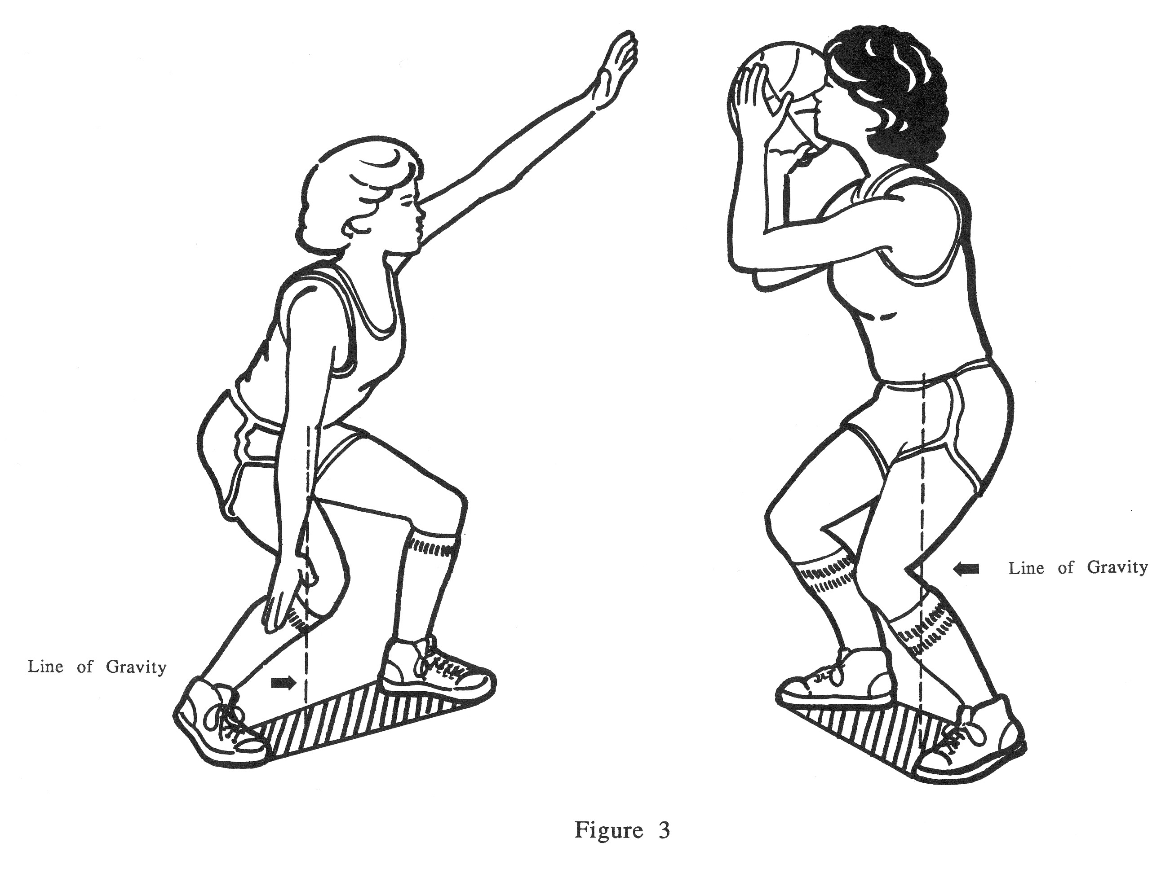

* The location of the centre of gravity usually changesas athletes' arms and legs move, and so does balance. If a swimmer on the edge of a pool deck moves his or her arms forward, the centre of gravity moves forward, and balance may be lost.
* **External Weight**
* The additionofan external weight changes the position ofthe centre of gravity, and problems with stability may increase. The centre of gravity of an athlete lifting a weight, for example, is in the centre of the athlete's own weight plus the weight of the bar. Moving the bar too far forward or back can move the centre of gravity *outside* the base of support and lead to a loss of control.
* The loss of a body part can also create difficulties — after all, the centre of gravity shifts, and adaptations are necessary. For instance, some one-legged high jumpers have trouble using a fast hoppingapproach to the bar because of their asymmetric weight distribution.
* **Movement and Balance**
* In some skills, athletes move *and* try to keep their balance. For example, wrestlers lowertheir centre of gravity while their opponent tries to pull them off balance — it helps them *stay* balanced. And if an opponent tries to pull wrestlers off balance in a forwarddirection, they can shift their weight over the backedge of the base.
* **Instability**
* There are many times when athletes want to be *less stable* so they can move asfast as possible in a certain direction. For example, in the sprint start, athletes move their centre of gravity far forward over the base of support, thus *decreasing* their stability in the direction of the run. This position helps them start faster *—* when they bring their hands up, they are in an unstable position and tend to topple forward, because the centre of gravity is now *outside* the base of support.
* In cases where the base of support has been *entirely* removed, athletes are *totally* unstable. For instance, wide receivers in football are totally unstable when they are in the air, and so they are susceptible to losing their balance when hit.

### Principle #2: Use All Joints in Order

#### **Statement of the Principle**

To achieve maximum speed of a body segment or object, use all joints in order, from largest and slowest to smallest and fastest, through the largest range of motion possible.

#### **Key Terms**

* **Joint range of motion** refers to the amount of *movement* at a joint. Joint range of motion is measured in degrees (°).

#### **Applications of the Principle**

* **Maximum Possible Speed**
* Maximum possible speed at impact or release is the goal of many skills. Such speed is achieved by addingthe speeds of the preceding segments and transferringthis speed to the final segment or to the implement — hand, foot, racquet, stick, etc. — used to propel another object. For example, to maximize speed, a javelin thrower does as follows:
* The transition from one joint to another starts with the hips, trunk and shoulders perpendicular (or facing away from) the desired direction of the throw.
* As the athlete starts the throw, the trunk and hips rotate first, causing the upper body to lag behind. Having a body part lag behind places a significant stretch on the muscles, which will result in a greater muscle contraction. This will contribute to the speed of the body segment or object.
* As the athlete continues the throw, the shoulders rotate through and the arm lags behind.
* As each segment rotates in sequence, speed increases so that maximum speed is transferred to the javelin at the point of release.
* **Speed and Implement Length**
* The speed at the end of a body segment or implement is directly proportional to the implement's length, *provided the speed of the swing is the same*. Golfers therefore use longerclubs to hit the ball farther—they can hit the ball twice as fast if they can swing at the same speed with a club twice as long.
* **Skills Calling *Mainly* for Maximum Speed**
* Skills calling *mainly* for maximum speed are timed sequentially — larger, slower joints *start* the movement, and faster joints contribute *once the preceding joint reaches peak speed.* The baseball throw is a skill of maximum speed; athletes use — in order — the legs, pelvis, trunk, shoulder, elbow, wrist, and fingers.
* **Maximum Force**
* In skills calling *mainly* for maximum force, athletes should perform *slower, controlled movements at high intensity.* In these skills, body segments usually move *at the same time,* especially if the object is heavy or both hands are used at once. The squat in weightlifting is a skill of maximum force.
* The more joints athletes use in a movement, the more muscles they contract and the more force they can exert. For example, a hard slapshot in hockey involves the legs, hips, shoulders, arms, and stick — and leaving out *one joint* would reduce the shot's force. And football kickers with soccer-style technique are bringing in one more joint movement to provide force to the leg — the rotation of the hip joint *inward* during the swing.

### Principle #3: Impulse

#### **Statement of the Principle**

Impulse is the product of force and the length of time the force is applied.

**Key Terms**

* **Momentum** is the amount of *motion* an athlete or object has developed.
* **Linear momentum** isthe amount of linear motion, and it equals *mass* times *velocity.*
* **Impulse** refers to the application of force over a period of time that results in a change in the amount of momentum an athlete or object has. This relationship is referred to as the impulse-momentum relationship.

**Applications of the Principle**

Impulse can be generated over a long or short period of time. Impulse is critical in sport situations that require changes in speed and direction of movement, and it applies most commonly to jumping skills.

* **Maximum Force over a Short Period**
* Sprinters start in a flexed position and apply as much force as possible over a short period of time to increase speed from rest. The impulse is produced for the entire time the athlete is in contact with the blocks. The athlete drives his or her limbs through a full range of motion to create more force.
* **Smaller Force over a Longer Period**
* The running start in bobsleigh is one of many situations in sport where impulse is created by applying a smaller force over a longer period of time.
* Bobsledders have up to 65m to increase the speed of their sled. This is necessary because the sleds are so heavy. The athletes lean into the sled and plant the front foot while flexed at the knees and hips, then extend forcefully, propelling the sled forward.
* The more force the team creates over the starting distance, the sooner the team can jump into the sled, and the higher the speed it can reach earlier in the race.
* **Novice versus Experienced Athletes**
* Novice athletes have less range of motion than experienced athletes during force production. The arm drive of novice athletes is also more limited than that of experienced athletes, reducing the net force produced. The result is a smaller impulse, which produces a slower change in speed.
* **Change in Direction**
* Athletes often need to make sudden changes in direction while moving at high speeds. For example, a football player avoiding would-be tacklers must produce maximal force in a minimal time to propel himself or herself as far away from the defender as possible without giving away the intended change of direction. If the football player does not produce enough impulse, the change in direction will be reduced, and so will the player’s ability to avoid the defender.
* **Force Absorption**
* Forces often have to be *absorbed,* for example, to prevent injury, to catch an object, or to control an object. Force absorption occurs when athletes catch a fly ball, receive a pass in broomball, or land on mats in karate and judo.
* In cases where force absorption is necessary, the athlete or object has developed a certain amount of momentum*,* and it has to be dissipatedover time or distance. This change in momentum requires the application of an impulse. For example, skilled fielders catching a fly ball reach out with the glove and flex the arms inward as the ball contacts the glove; this increases the time for which force is applied. By contrast, unskilled players often keep the glove in one place at impact, and *all* the force is applied at once.
* **Range of Motion**
* In general, if a skill calls for maximalapplication of force, the joint should be moved through a largerrange of motion — force is applied for longer, and impulse is greater.
* In the volleyball spike jump, for example, the player who crouches the deepest before jumping often jumps highest because the leg joints move through the greatest range of motion.

### Principle #4: Reaction Forces

#### **Statement of the Principle**

For every action, there is an equal and opposite reaction.

#### **Key Terms**

* **Linear motion** is any movement that occurs along a straight or curved path where all parts of the body or object move an equal distance in the same direction.
* **Angular motion** is motion that occurs about an axis of rotation. For every action produced in the air, there is an equal and opposite reaction about the same axis of rotation.

#### **Applications of the Principle**

This principle is the foundation of all movement and can be observed in all sport skills. It applies to both linear and angular motion.

* **Linear Motion**
* **Sprinting.** As the sprinter pushes against the starting blocks (the action), he or she exerts a force against the block. Because of the resistance of the ground, the blocks in effect push back (reaction force). The reaction force is the same size as the force the athlete applied to the blocks, but opposite in direction.
* **Speed Skating.** Short track speed skaters push against the ice (applies a force against the ice) through the blade of the skate. The ice pushes back on the skate blade with a force equal in size but opposite in direction. Without this reaction force, the skate blade would continue to slide along the ice, and no forward movement of the athlete would occur.
* **Angular Motion**
* **High Jumping.** To clear his or her feet, a high jumper moving over the bar brings the head up (the action), which causes the feet to come up in reaction to the movement of the head.
* **Hurdling.**
* Approaching the Hurdle. As theathlete approaches the hurdle near top speed, he or she must quickly and efficiently raise the lead leg to a position slightly above the hurdle to avoid hitting the hurdle. To accomplish this, the athlete flexes the upper body forward and down when pushing off the ground. The axis of rotation is at the waist. The upper leg must come up to counter the movement of the upper body. This reaction of the lower leg helps the athlete raise the lead leg more quickly.
* Clearing the Trail Leg. As the athlete clears the hurdle, he or she must clear the trail leg, which is positioned horizontally and out to the side. As the athlete rotates the leg to return it to his or her midline to continue the running stride, the upper body counters this movement by rotating about a vertical axis of rotation through the trunk.

### Principle #5: Direction

#### **Statement of the Principle**

In accuracy skills, the path of the hand or implement must be aligned with the target for as long as possible during delivery; this is called *flattening the arc*. *Flattening the arc* means that the pathway of the arm or implement does not trace out a perfect parabolic arc during delivery but is flattened to keep the hand or implement facing forward for a longer period of time.

#### **Applications of the Principle**

* **Importance of a Long Step in the Direction of the Target**
* In the windmill pitch in softball, skilled pitchers flatten the arc of their arm by, among other things, taking a long step forward and using a full range of trunk rotation and shoulder flexion. This extends the arm’s pathway and flattens the arc during release. Similarly, in the forehand drive in tennis, the player flattens the arc of the arm by, among other things, taking a long step forward.
* By contrast, novice softball pitchers often fail to take a step in the direction of the pitch, thus reducing their ability to flatten the arc. This reduces their ability to flatten the arc.
* **Importance of Rotation and Flexion**
* In the forehand drive in tennis, the player flattens the arc of his or her arm with, among other things, a full range of arm motion in horizontal flexion, often accompanied by wrist flexion and lower-arm rotation. Rotation of the trunk in the direction of the hit also helps extend the arc of the racquet.
* **Error Detection and Correction**
* Look for abbreviated movements when athletes are not flattening the arc as well as they should be able to, given their stage of development.
* For example, if a young baseball player has a poor swing, carefully observe his or her step forward, trunk rotation, trunk flexion, range of arm movement at the shoulders. If any of these movements are abbreviated, the swing will be shortened and therefore less effective.

### Principle #6: Angular Motion

#### **Statement of the Principle**

Angular motion is created by the application of a force acting at some distance from the axis of rotation of a body or object. In other words, the force does NOT act directly through the centre of gravity.

#### **Key Terms**

* **The axis of rotation** is an imaginary line perpendicular to the plane of rotation and passing through an athlete’s or object’s centre of gravity.
* **Linear motion** is motion along a straight line. Linear motion is produced by the application of a force that is acting directly through the athlete’s or object’s centre of gravity. For example, if the force applied directly through the body’s centre of gravity is vertical, the athlete’s linear motion will be vertical.
* **Angular motion** is motion about a fixed point or fixed axis.
* **Torque** equals force times the perpendicular distance from the force to the axis of rotation.
* **Moment of inertia** is a measure of resistance to angular motion. Moment of inertia depends on mass and the square of the distance between the centre of gravity and the axis of rotation.For example, in the leg recovery in sprinting, the distance from the axis is the distance from the hip joint to the centre of mass of each leg segment (see figure below). When sprinters tuck their leg by flexing the knee maximally, the distance from the hip to the lower leg segment can decrease by as much as one-half; this decreases the moment of inertia by the square of one-half, or by as much as one-quarter!

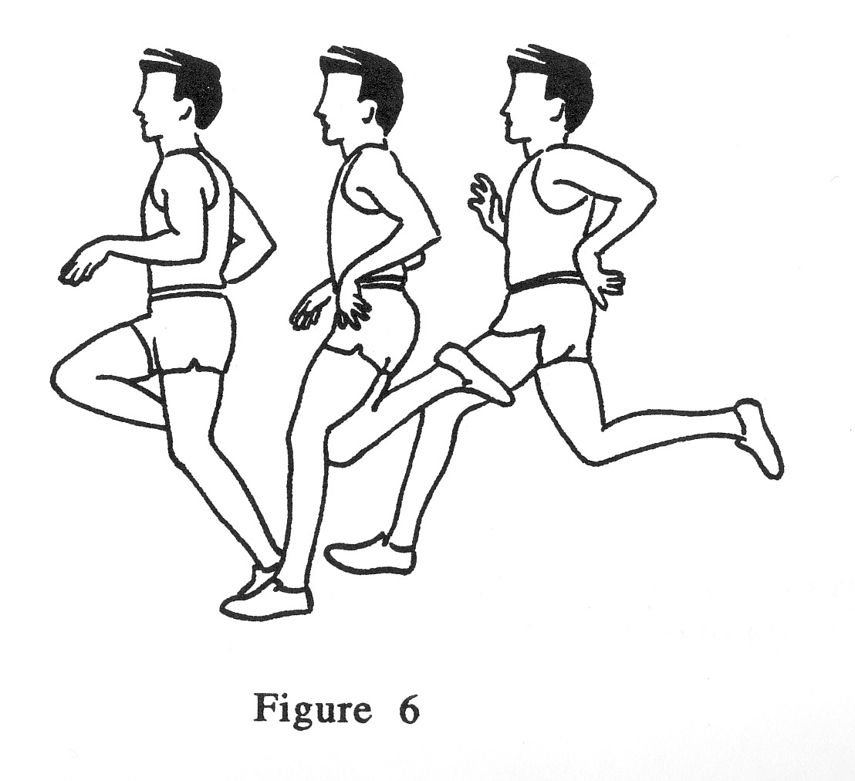

#### **Applications of the Principle**

* **Rotation of the Entire Body**
* In many cases, gravity is one of the forces acting at some distance from the axis of rotation. For instance, as a diver leans back, his or her centre of gravity moves behind the axis of rotation, which is the edge of the tower as long as the diver is in contact with it. Because of the pull of the earth, the athlete’s mass is the applied force. And since that force is acting at some distance from the axis of rotation, the result is a torque and angular motion once the diver is airborne.

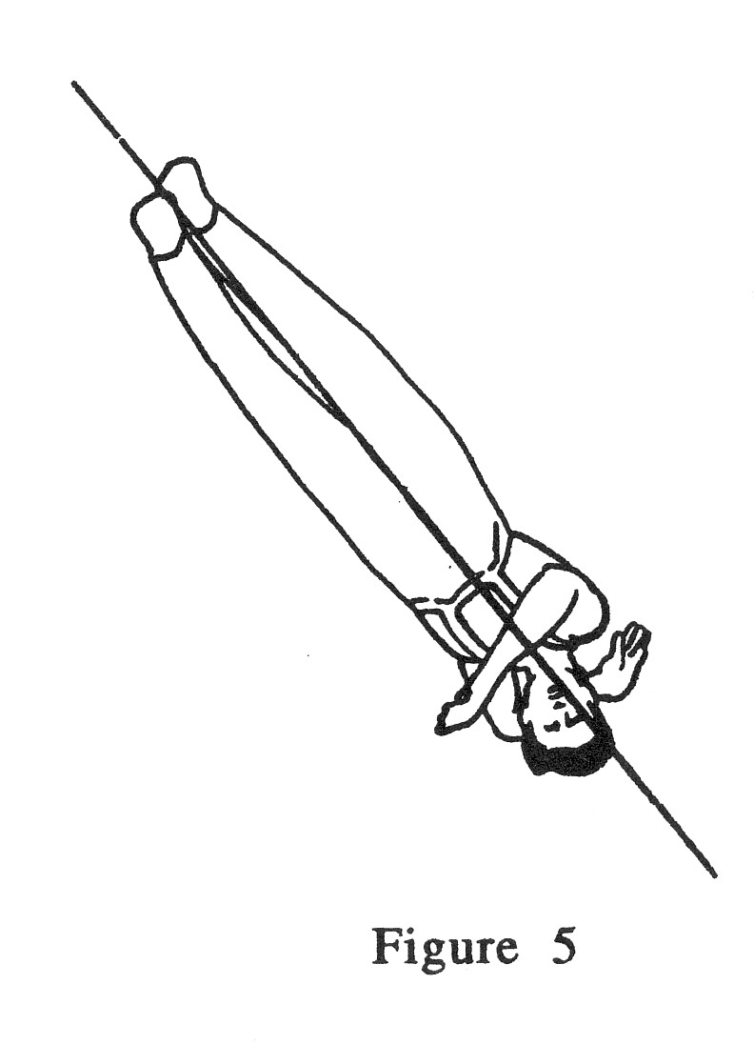

* When a linebacker tackles an opponent by grasping the feet, the linebacker is applying an off-centre force that will cause the whole body to rotate about the feet. Similarly, wrestlers try to pull their opponents over by applying forces to the shoulders, thereby creating torque and perhaps rotating the opponent to the canvas.
* **Moment of Inertia and Energy Expenditure**
* Muscles have to generate torque to move body segments or implements about a given axis of rotation. If athletes can reduce their moment of inertia, less torque will be needed to move body segments or implements about a given axis of rotation.
* For example, swimmers who flex their shoulder and elbow as they move the arm closer to the body during recovery reduce the moment of inertia of their arm, decrease the amount of torque required to rotate the arm about the shoulder joint, and lower their energy expenditure. Similarly, paddlers who bend their arms and bring the paddle closer to their body use less energy in their recovery.
* The gait of amputee runners illustrates the adaptations necessary when the moment of inertia *cannot* be reduced. Prosthetic limbs remain extendedduring recovery, and this extended position slows down the recovery. Athletes often compensate by taking twohopping steps on their normal limb while the prosthetic limb is being recovered, and they can take a longer stride with this limb. These actions may partiallycompensate for the energy it takes to recover an extended limb.
* **Free-Limb Motion**
* Free limbs can assist in the production of rotation AND increase the magnitude of forces against the ground*.* Free limbs must, however, completetheir swings while athletes are still in contact with the ground; otherwise, no reaction forces are produced!
* There are many examples of free-limb motion. The acceleration of free limbs upward during sprinting produces a reaction force downward on the body; this force is transmitted to the supporting surface and produces an equal and opposite reaction force against the limbs. Similarly, high jumpers and long jumpers forcefullyswing their free leg and arms upward while the takeoff leg is extending — it increases the forces driving them upward and forward.
* **Rotation of Projectiles**
* Whether they are rifle bullets, javelins, or baseballs, all projectiles tend to follow the same path during flight. This flight is a parabolic trajectory. See the figure below.

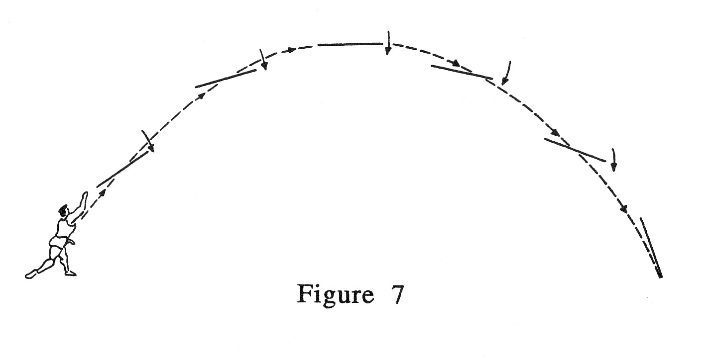

* The ability to *alter* this normal flight path is one of the keys to performance in some sports (baseball, softball, or tennis, for instance).
* Spin occurs when off-centre forces are applied to objects at release. Spiral passes in football result from the application of an off-centre force to the side of the ball — it creates spin and stabilizes flight (see the figure below).

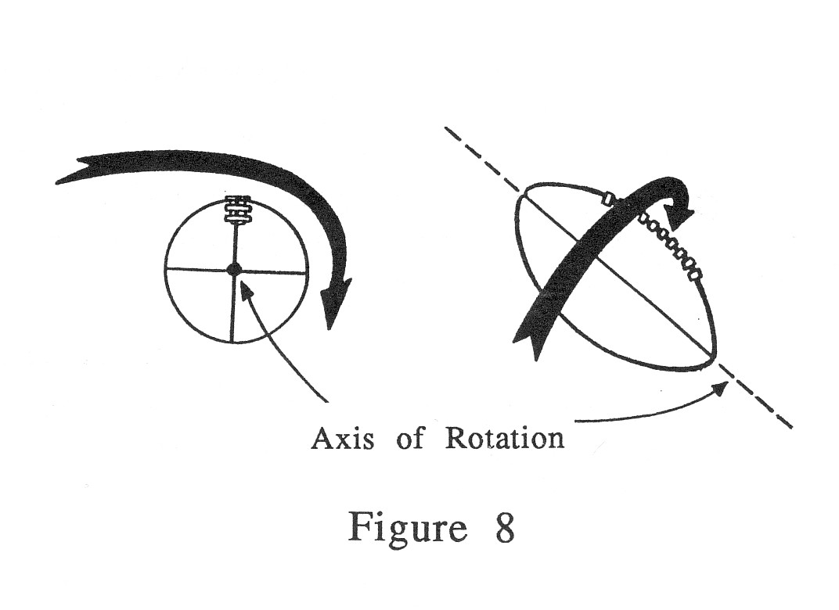

* Spinning projectiles are surrounded by thin layers of air during their flight. These thin layers are called boundary layers. As a spinning object moves in one direction, a flow of air is created, and it moves in the opposite direction past the object. On one side of the spinning object, the boundary layer meets air flowing in the opposite direction, and turbulence is created; this turbulence results in the formation of a high-pressure area. On the other side of the spinning object, the boundary layer moves in the same direction as the air flow, and an area of low pressure is created. Spinning objects move toward the area of low pressure. See the figure below.

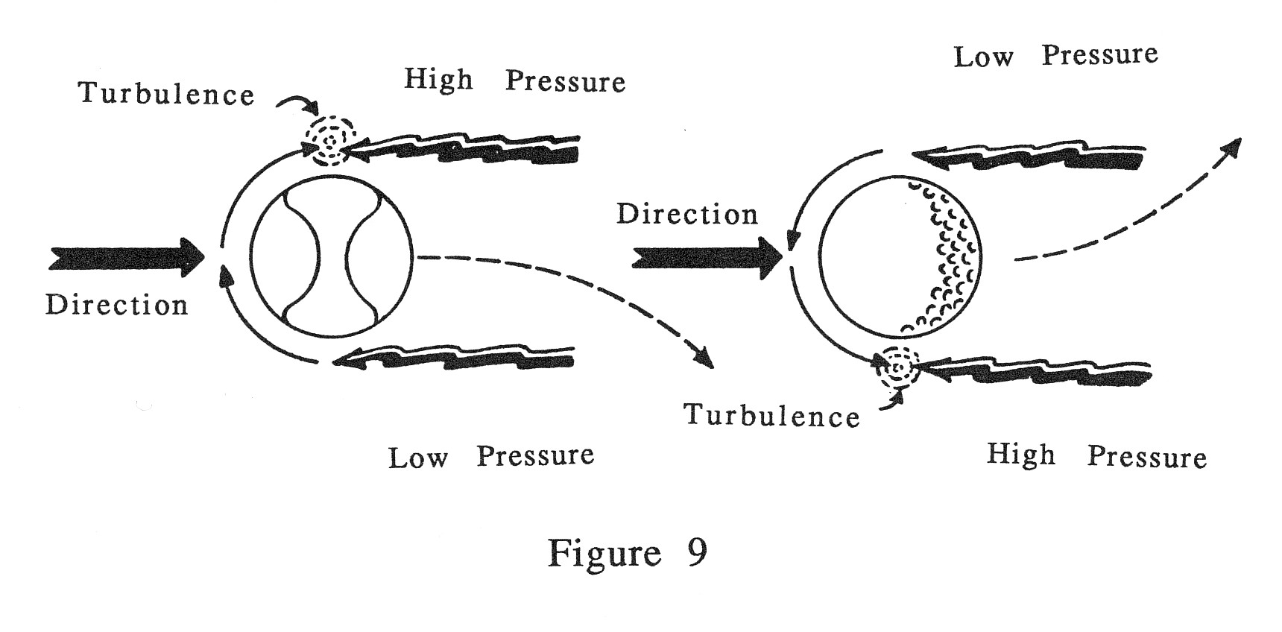

* This movement toward low-pressure areas explains, for example, why a topspin tennis drive drops downward toward the court more rapidly than one with no spin and why golf shots with backspin stay in the air longer than would be expected.
* The same thing happens when *sidespin* is imparted to objects. For instance, when right-handed golfers apply right spin to a ball, a low-pressure area develops on the right side of the ball, and a "slice," or curve to the right, results. The opposite happens in the case of left spin — a "hook," or curve to the left, occurs. Some professional golfers deliberately apply spins to produce curved shots on curved fairways.
* Almost all projectiles have some spin. Spin makes the flight of projectiles more stable — it prevents them from wobbling in the air.
* Objects with little or no spin behave differently. In particular, such objects behave more erratically*.* Seams and irregularities in the object's surface still cause turbulence in the oncoming air, and the object still moves toward the area of low pressure, but the low spinning speed causes the location of this turbulence and the high- and low-pressure areas to vary.

### Principle #7: Angular Momentum

#### **Statement of the Principle**

The angular momentum of a person or object remains constant while airborne, unless external torque is applied.

This principle is known as the law of conservation of angular momentum.

#### Key Terms

* **Angular momentum** is the amount of angular motion possessed by an athlete or object. Athletes possess angular momentum in situations in which they are free to rotate about an axis. Angular momentum is the product of an athlete’s moment of inertia and his or her angular velocity.
* **Angular velocity** refers to how fast a body or object is spinning; it is usually measured as degrees per unit of time.

#### **Applications of the Principle**

The conservation of angular momentum is very important in airborne sports. Close attention must be paid to how athletes can manipulate their moment of inertia by altering the positions of their body segments to increase and decrease angular velocity, i.e., increase and decrease the rate at which they spin.

* **Figure Skating**
* As figure skaters enter a spin, they position their limbs away from their axis of rotation to increase their moment of inertia. This in turn allows them to decrease their angular velocity, or rate of spin. As skaters continue to spin, they move their limbs closer to their axis of rotation, which decreases their moment of inertia and increases their rate of spin. Lastly, as skaters exit their spin, they reduce their angular velocity by moving their limbs away from their axis of rotation, which increases their moment of inertia.
* Novice skaters are less skillful both at manipulating their moment of inertia and at applying torque to the ice surface.

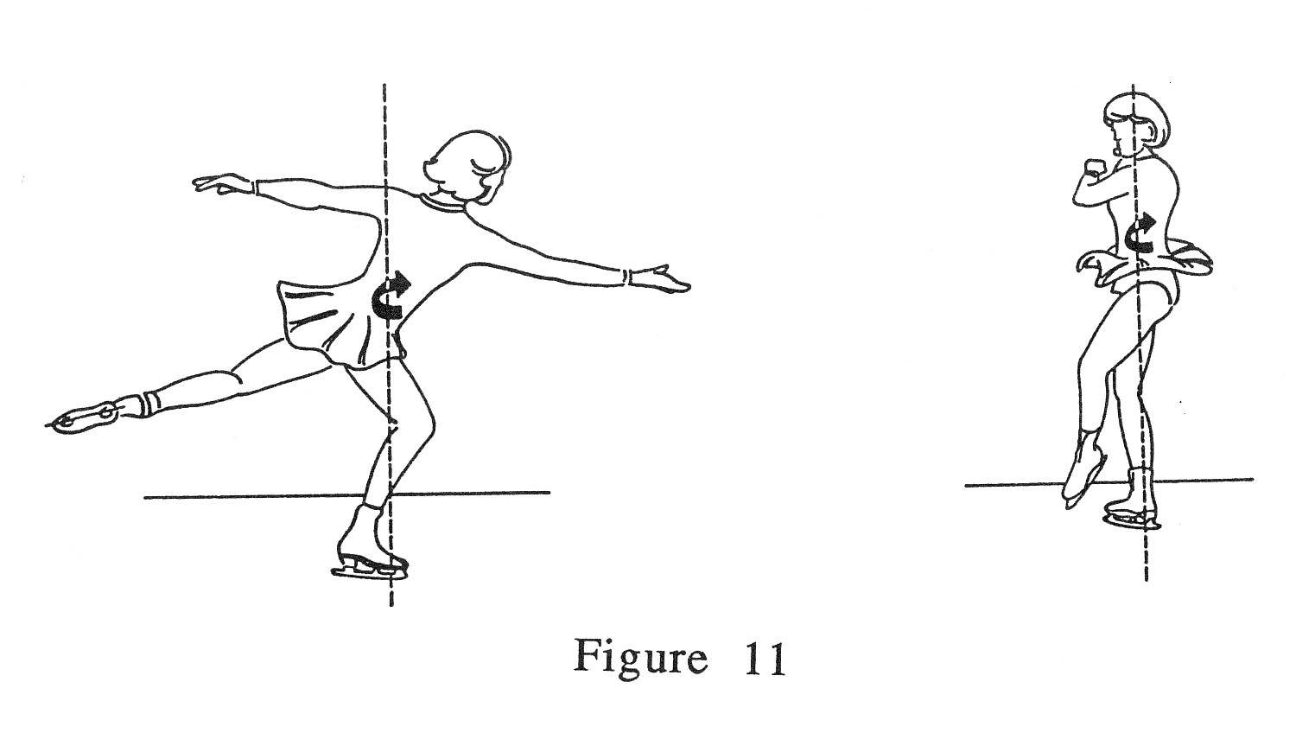

* **Diving**
* Changing their moment of inertia affects divers’ angular velocity. For example, divers wishing to do high-velocity spins assume a tuck position; those wanting to perform medium-velocity spins assume a pike position; and those whose goal is slow-velocity spins assume the layout position.
* **Long Jump**
* In the long jump, athletes manipulate their angular momentum to prevent unwanted forward rotation of their trunk. Because of the high speed of their run-up, long jumpers have a tendency to rotate forward at the trunk. To counter this, long jumpers perform a hitch-kick while airborne. This allows them to store all their angular momentum in their limbs and prevents their trunk from rotating forward prematurely, which would cause their feet to land in the pit earlier.

### Principle #8: Streamlining

#### **Statement of the Principle**

The resistance to a body or object as it moves through air or water is determined by its size, surface, and shape. More specifically, the resistance to the motion of a body or object moving through air or water is increased when the object is not streamlined, i.e., has a large surface area or a rough surface.

#### **Key Terms**

* **Streamlining** refers to minimizing the surface area of an object facing the direction of motion and making this surface assmooth as possible sothat the flow of water or air past it is smooth*,* not turbulent. When these lines of flow are parallel, the flow is said to be *streamlined*. The perfect streamlined shape is the foil: rounded in the front and tapered in the back to ensure smooth fluid flow and minimal turbulent flow.

#### **Applications of the Principle**

Streamlining is important in sports that require athletes to move through air or water in the shortest time possible. The greater the athlete’s speed, the more important streamlining is, as higher velocities result in higher drag forces.

* **Swimming**
* Swimmers can improve their streamlining by aligning their bodies horizontally in the water, wearing swim suits that decrease the water’s resistance their movement, cutting their hair short, and shaving their body hair.
* **Speed Skating**
* In speed skating, athletes decrease air resistance by flexing their knees and bending at their waist to decrease the cross-sectional area exposed to the oncoming air. Speed skaters also wear special suits that decrease air resistance by smoothing out their “skin” surface and allowing the air to move more freely around their body.
* **Sliding Sports**
* Downhill skiers wear thin nylon ski suits and streamlined helmets to decrease air resistance. Even the poles in downhill skiing contribute to streamlining: they are shaped to conform to the athlete’s body and decrease the overall surface area. Skiers also bend their legs and lean well forward to decrease the area of the body facing the oncoming air.
* Athletes competing in bobsled, luge, skeleton, and skiing all wear suits specially designed to decrease air resistance. Even ice hockey players now wear jerseys are form-fitting and made with smoother material**.**

### Biomechanics Principles: Summary Table

| Biomechanical Principle |  | Athletes' Actions |
| --- | --- | --- |
| **Principle #1: Balance and Stability**  When athletes want to become stable, they should |  | lower their centre of gravity  widen their base of support  place their centre of gravity in the middle of the base of support  increase their mass |
| When athletes want to move quickly (become less stable), they should |  | raise their centre of gravity  narrow their base of support  move their centre of gravity outside the base of support  decrease their mass |
| **Principle #2 Use All Joints in Order**  When athletes want to exert maximum force, they should |  | use as many joints as possible  use joints simultaneously |
| When athletes want to produce maximum speed, they should |  | use as many joints as possible  use all joints in order, from largest and slowest to smallest and fastest |
| **Principle #3: Impulse**  When athletes want to apply maximum force, they should |  | move their joints through a larger range of motion  Decrease surface area in which the force is applied |
| **Principle #4: Reaction Forces**  When athletes want to move in one direction, they should |  | apply a force in the opposite direction |
| **Principle #5: Direction**  When athletes want to hit a target, they should |  | align the path of their hand or the implement with the target for as long as possible |
| **Principle #6: Angular Motion**  When athletes want to create motion about a fixed point or fixed axis, they should |  | apply force some distance from the axis of rotation |
| **Principle #7: Angular Momentum**  When athletes want to spin faster, they should |  | decrease their moment of inertia |
| **Principle #8: Streamlining**  When athletes want to increase their speed in air or water, they should |  | be as streamlined as possible |

For more information on biomechanics and sport technique, see the second edition of *Sport Mechanics for Coaches*, by Gerry Carr and published in 2004 by Human Kinetics.

### Progression in Technique

Athletes move through a progression as they improve their technique. Here are some tips on how to develop a desired technique more quickly:

* First, the skill should be one smooth motion with no pauses. Each segment should start moving as the previous one reaches maximum speed in a fluid motion.
* Second, look for a stretch on the limb muscles. In overhand sport skills, the anterior chest muscles should usually be on stretch. For example, when a volleyball player serves, there is a huge stretch on the pectoral muscles. By contrast, in kicking sports skills, the anterior thigh muscles or quadriceps should be on stretch.
* Third, look for joints being used out of sequence. The big trunk, shoulder, and hip joints need to be used before the knee, ankle, elbow, and wrist joints.
* Fourth, ensure that the athlete has a long follow-through over which to decelerate his or her joints. This decreases the chance of injury by dispersing force over a larger time period.

## Ways to Communicate Measurement Findings on Performance to Athletes

|  |  |
| --- | --- |
| During Error Detection | During Error Correction |
| Tools | Tools |
| Statistical analyses  Statistical comparison to other athletes  Statistical comparison to an accepted standard of performance  Charts, tables, graphs  Computer-enhanced charts and graphs, e.g., force curves  Checklists | Statistical analyses showing changes  Statistical comparison to an accepted standard of performance showing closing of gaps  Charts, tables, graphs showing progress  Computer-enhanced charts and graphs, e.g., force curves showing changes  Checklists |
| Processes | Processes |
| Coach-athlete 1-1 discussion of a final  Athlete self-analysis checklist of performance – with or without videos  Coach checklist of athlete analysis followed by discussion  Peer assessment of an athlete’s performance with feedback – with or without videos or checklists  Group analysis of performance | Coach-athlete discussion on development factors  Before and after correction comparisons (videos) on changes  Personal reflection on changes – feelings, thoughts  Peer assessment with feedback  Visualization of expected performance  Group analysis of performance |